5.PCB Design of a custom line sensor

Objective

The purpose of this lab was to lay out a single sided PCB for a line sensor circuit that was required to have the right components, footprints, trace widths, connectors, ground plane, and mounting hole in order for it to eventually be manufactured, soldered, and used on a line following robot.

Procedure

The Proteus PCB project was initially created using the generic single layer option. The line sensor circuit previously designed in Proteus's schematic capture was entered using the LM358 op-amp, resistors, potentiometer, IR LED, photodiode, line detect LED, and output.

Once the circuit was laid out in schematic, the correct component footprints were associated with each component. The correct footprints for the LED's and the photodiode had to be assigned in particular, so the labels on the footprint matched the labels on the circuit in schematic.

Once the footprints were assigned to each component, the PCB was laid out. Care was taken to make sure that the size of the PCB remained less than 9 cm. All traces and pads were kept on the top layer. The trace widths for the signal traces and power traces were designated as 25 mil and 30 mil respectively. A ground plane and an M3 mounting hole were also incorporated into the board. Finally, the necessary manufacturing files were created that include the drill file (.DRL) and top copper file (.GBR).

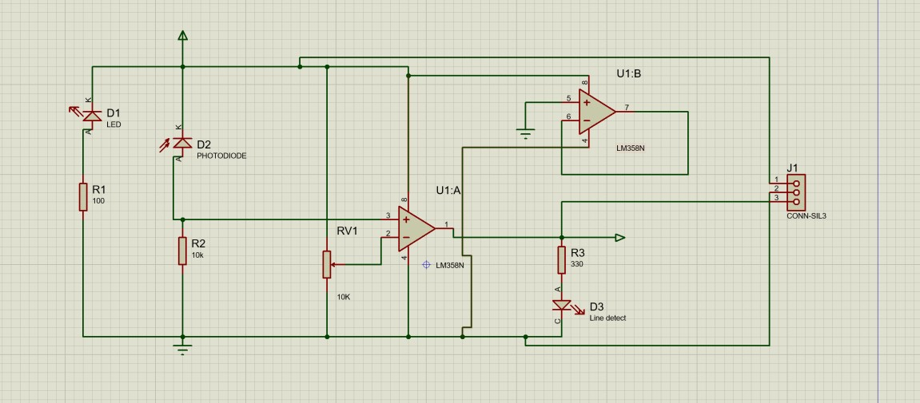
Figure 4Proteus simulation
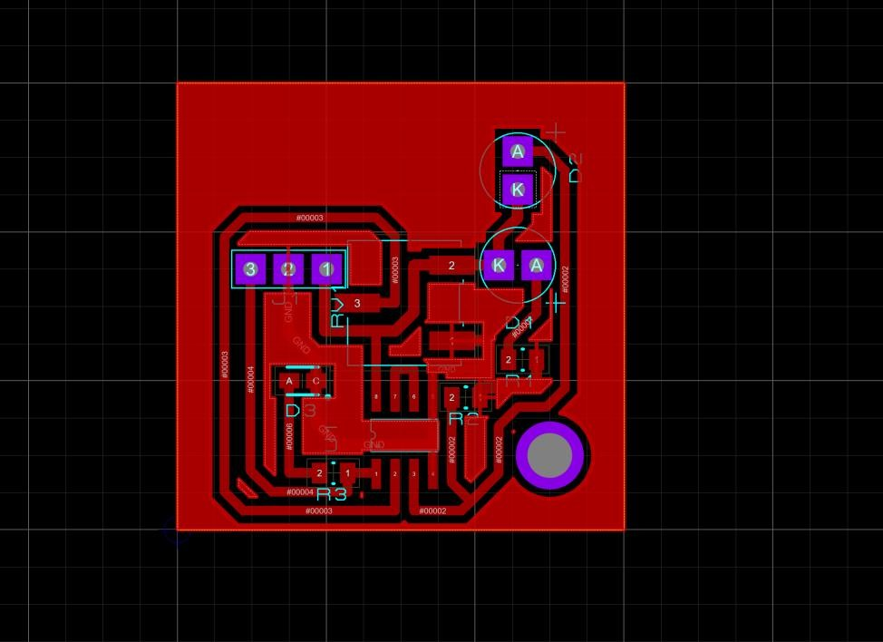
Figure 5PCB layout

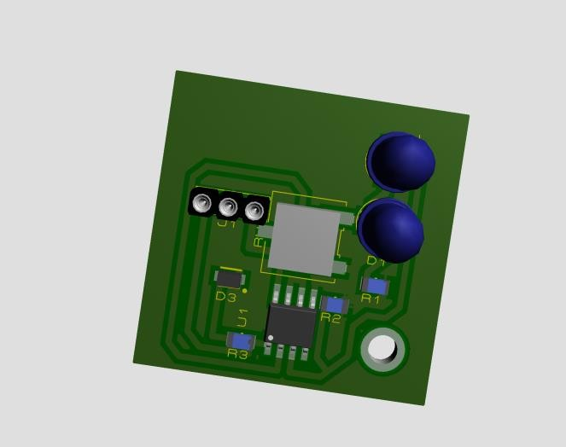

Figure 6 3D visualised PCB
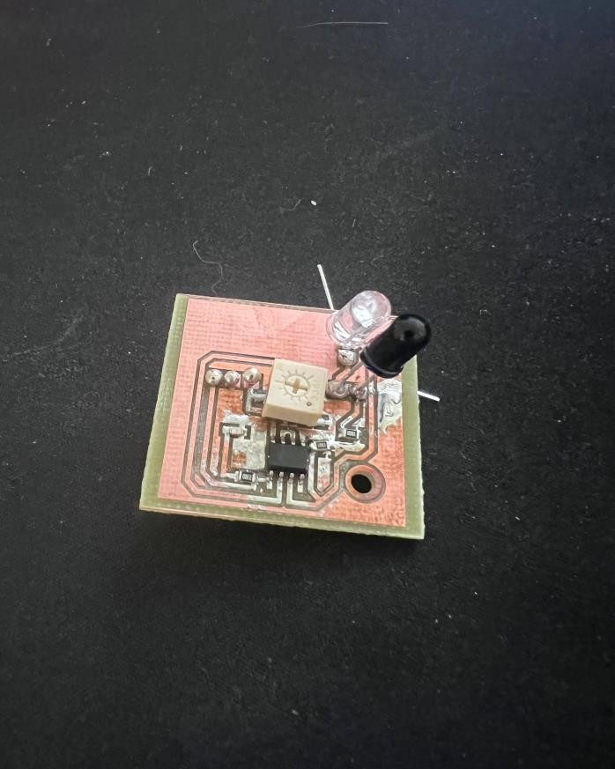
Figure 7 Soldered PCB

Conclusion

The lab was a success as a full PCB design of the line sensor module was created. The design adhered to all board size, track width, single-sided PCB, connector, ground plane, and mounting hole requirements. The final PCB could be sent to a manufacturer for the production process and be integrated in a line-following robot.

6.Robot Car Build

Aim
Design and assess whether the robot cars is capable of navigating through the black line track and achieving success in the obstacle avoidance test.
Setup
The setup for a car is placed onto and driven on. It is made of an Arduino board that is used to operate the car, two motors which are used to drive the wheels, line sensors situated on the front that can see and follow the black line, and finally an ultrasonic sensor placed on the front that can detect and recognize any obstacles in its pathway.

Component Arduino pin
Left line sensor D2
Right line sensor D3
Servo signal D4
Left motor speed ENA D5
Right motor speed ENB D6
IN1 | D8
IN2 | D9
IN3 | D10
IN4 | D11
Ultrasonic TRIG D12
Ultrasonic ECHO D13

Car was build by following Robot Car Construction Manual File which was provided by our lecturer.
Main components are: Line sensors, ultrasonic sensor, servo motor, dc motors , bridge and Arduino uno.

Aim is to make a line following car which will stop, if any objects are in front of the car, plus it follows the line at all times, and stops at the finish.

Logic of our project :

Initially, the Arduino senses the ultrasonic sensor that is located at the front part of the car. This is where the safety test comes in. When there is an obstruction detected through the sensor, the car comes to a stop. The vehicle remains still until the object is moved out of the way. Afterward, the car resumes tracking the line.

Next, the two line sensors on the underside of the car sense whether they are above the black line or on the white ground.

The car follows this logic:

Left sensor Right sensor What the car does
White | White | Move forward
Black | White | Turn left
White | Black | Turn right
Black | Black | Move slowly or stop, depending on junction/line

This happens because the black line should be in the middle of two sensors instead of directly below them. Thus, when two sensors detect white, then the car would consider itself being centered to the line.

When the left sensor detects black, the car goes too far towards its right side, and thus it makes the car turn left to make corrections.

If the right sensor detects black, the car drifts too much towards its left side, and thus it turns right to make the correction.

Motor control is done by motor driver bridge module. When you need your car to move forward, both motors rotate clockwise. If the robot needs to move left, the left motor stops or slows while the other one continues rotating forward. If the robot wants to turn right, the left motor keeps spinning forward while the right one stops or slows down.

Servo is needed to hold the ultrasonic sensor forward. In this case, the main task of this servo is just to maintain the forward position of the sensor in order to allow obstacle detection.

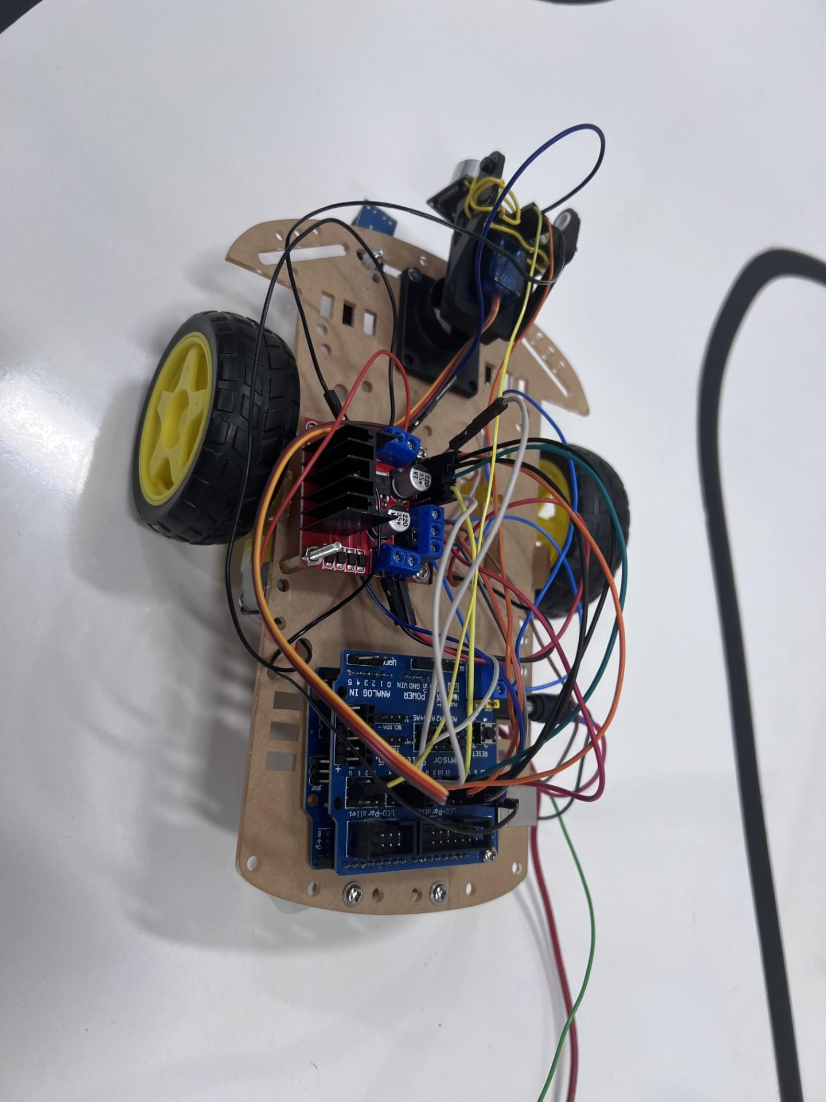
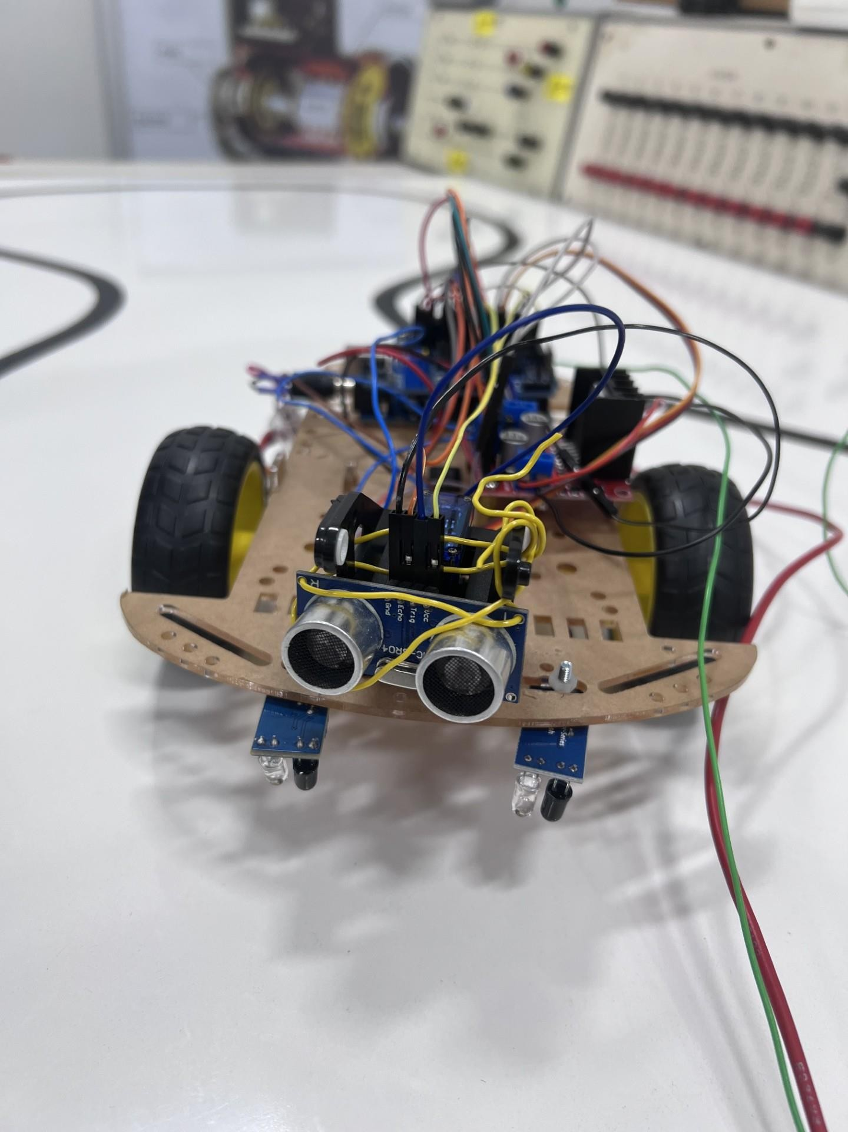

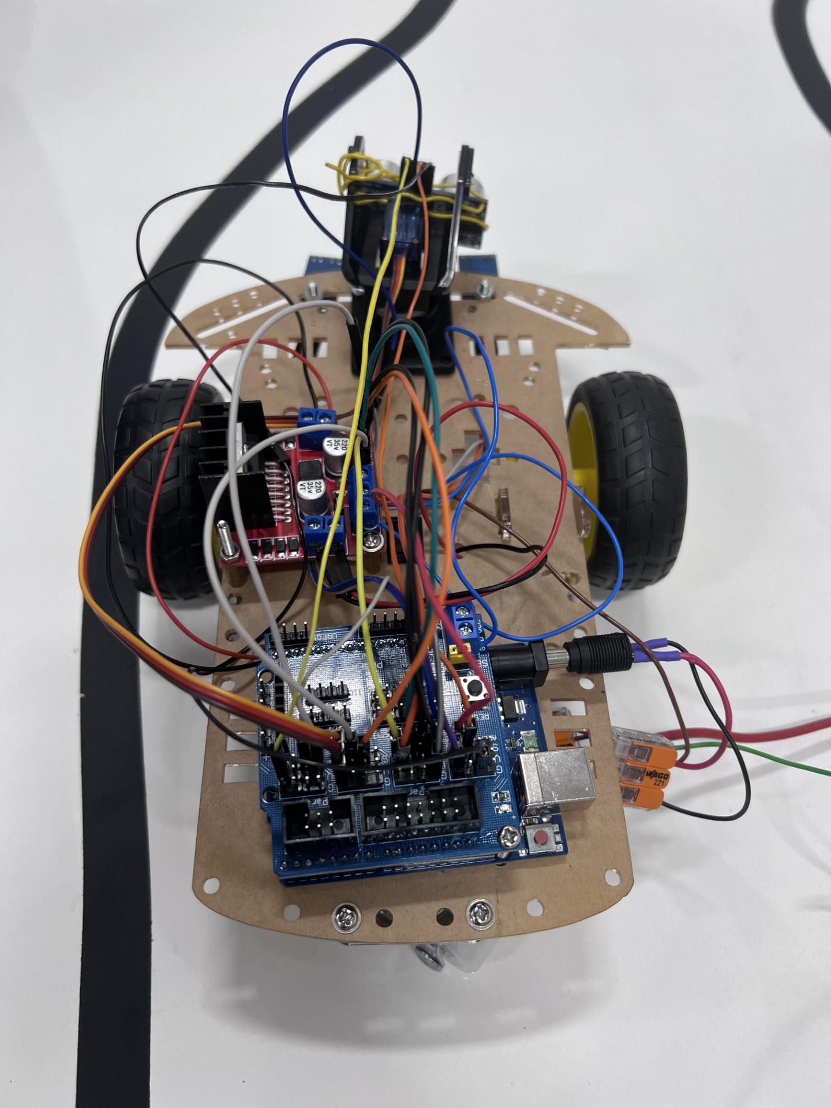

CODE

#include <Servo.h>

// Line sensors
#define LEFT_SENSOR 2
#define RIGHT_SENSOR 3

// Servo
#define SERVO_PIN 4

// Motor speed pins
#define ENA 5 // Left motor speed
#define ENB 6 // Right motor speed

// Motor direction pins
#define IN1 8 // Left motor
#define IN2 9
#define IN3 10 // Right motor
#define IN4 11

// Ultrasonic sensor
#define TRIG_PIN 12
#define ECHO_PIN 13

Servo ultrasonicServo;

// Settings
const int NORMAL_SPEED = 150; const int TURN_SPEED = 140;
const int SLOW_SPEED = 110;

const int OBSTACLE_DISTANCE = 15; // cm
const int SERVO_FRONT = 90;

// Sensor logic const int BLACK = LOW;
const int WHITE = HIGH;

void setup() { Serial.begin(9600);

pinMode(LEFT_SENSOR, INPUT);
pinMode(RIGHT_SENSOR, INPUT);

pinMode(ENA, OUTPUT); pinMode(ENB, OUTPUT);

pinMode(IN1, OUTPUT); pinMode(IN2, OUTPUT); pinMode(IN3, OUTPUT); pinMode(IN4, OUTPUT);

pinMode(TRIG_PIN, OUTPUT);
pinMode(ECHO_PIN, INPUT);

ultrasonicServo.attach(SERVO_PIN);
ultrasonicServo.write(SERVO_FRONT);

stopMotors();

Serial.println("Line Following Car Started");
}

void loop() {
ultrasonicServo.write(SERVO_FRONT);

int distance = getDistance(); Serial.print("Distance: ");
Serial.print(distance);
Serial.println(" cm");

// Stop if object is detected
if (distance > 0 && distance <= OBSTACLE_DISTANCE) { stopMotors();
Serial.println("Object detected - STOP");

// Wait until object is removed while (true) {
distance = getDistance();

if (distance > OBSTACLE_DISTANCE || distance == 0) { Serial.println("Object removed - Continue"); delay(300);
break;
}

stopMotors();
delay(100);
}
}

int leftValue = digitalRead(LEFT_SENSOR);
int rightValue = digitalRead(RIGHT_SENSOR);

bool leftBlack = (leftValue == BLACK);
bool rightBlack = (rightValue == BLACK);

Serial.print("Left: ");
Serial.print(leftValue);
Serial.print(" Right: ");
Serial.println(rightValue);

// Line following logic if (!leftBlack && !rightBlack) {
// Both sensors on white, black line is between sensors moveForward(NORMAL_SPEED);
Serial.println("Forward");
}
else if (leftBlack && !rightBlack) { // Left sensor sees black, turn left turnLeft();
Serial.println("Turn Left");
}
else if (!leftBlack && rightBlack) { // Right sensor sees black, turn right turnRight();
Serial.println("Turn Right");
}
else if (leftBlack && rightBlack) {
// Both sensors see black, move slowly forward moveForward(SLOW_SPEED);
Serial.println("Both black - Slow Forward");
}

delay(50);
}

// Ultrasonic distance function int getDistance() { digitalWrite(TRIG_PIN, LOW);
delayMicroseconds(2);

digitalWrite(TRIG_PIN, HIGH); delayMicroseconds(10);
digitalWrite(TRIG_PIN, LOW);

long duration = pulseIn(ECHO_PIN, HIGH, 25000);

if (duration == 0) {
return 0;
}

int distance = duration * 0.034 / 2; return distance;
}

// Motor control functions void moveForward(int speedValue) { digitalWrite(IN1, HIGH);
digitalWrite(IN2, LOW);

digitalWrite(IN3, HIGH);
digitalWrite(IN4, LOW);

analogWrite(ENA, speedValue); analogWrite(ENB, speedValue);
}

void turnLeft() { digitalWrite(IN1, LOW); digitalWrite(IN2, LOW);

digitalWrite(IN3, HIGH);
digitalWrite(IN4, LOW);

analogWrite(ENA, 0);
analogWrite(ENB, TURN_SPEED);
}

void turnRight() { digitalWrite(IN1, HIGH); digitalWrite(IN2, LOW); digitalWrite(IN3, LOW); digitalWrite(IN4, LOW);

analogWrite(ENA, TURN_SPEED);
analogWrite(ENB, 0);
}

void stopMotors() { digitalWrite(IN1, LOW); digitalWrite(IN2, LOW);

digitalWrite(IN3, LOW); digitalWrite(IN4, LOW);

analogWrite(ENA, 0); analogWrite(ENB, 0);
}

Results

Robot Car Project Results

The robot car was put to the test to determine if the circuit, the line sensors, motor control, and the C program functioned together appropriately. The primary goal was to see the robot successfully follow a black line as well as appropriately responding during both line-following and obstacle avoiding situations.

In general, the robot car did work, however the operation of the robot car was somewhat inconsistent. During the testing there were some instances that the robot correctly followed the black line, however there were other instances where it would turn the wrong way or simply ignore the black line altogether. This indicates the system only partially worked correctly and needed to be finely tuned.

Circuit and System Testing

The robot car circuit was constructed and tested using the schematic as well as Proteus simulation. The primary components of the circuit involved the microcontroller, the motor driver, DC motors, line sensors, power supply, and the obstacle sensors.

During testing, the circuit powered on, and the motors responded appropriately to the microcontroller. The motors were controlled by the motor driver, and were responsive to the line sensors' signals that the sensor readings change between black and light colored surface.

However the readings on the actual robot car were not always the expected behavior. Sometimes the robot responded to the sensors correctly, while other times it turned the incorrect direction or continued to run straight without following the black line. Possible reasons for this include: Incorrect sensor readings, sensor misalignments, lighting issues, unbalanced motor speeds, or issues within the control logic.

Test Condition | Expected Response | Actual Result
Left sensor on black line | Robot should turn/correct left | Sometimes successful
Right sensor on black line | Robot should turn/correct right | Sometimes successful
Both sensors on light surface | Robot should move forward | Mostly successful
Black line detected | Robot should follow the line | Not always successful
Sensor too far from track | Weak or incorrect reading | Needed adjustment
Sharp turn on track | Robot should turn with the line | Sometimes went the wrong way

From the experiments it appeared that the sensors functioned at their best if they were close to the track, and at the right angle. If not in the right place, the sensors did not always detect the black line and some times the car went over the black line ignoring its presence and continued traveling in the wrong direction, thus rendering the line tracking inconsistent.

One fault that occurred was when the motors would turn in the wrong direction, thus not back towards the black line, and instead away. Motors also did not always run at the same speed, causing the car to pull to the right.

Results of the Obstacle Avoidance System

The obstacle detection system was implemented by placing an object in front of the robot car. The robot could detect the object, however it would react to it but only dependent on the placement of the sensor. Also dependent was the distance between the object and the robot.

The obstacle avoidance system was partially successful. It could recognize an object, but would also react to it but not always smoothly. More test runs would be required to increase the ability to detect obstacles smoothly especially at higher speeds.

Problems encountered: Several problems were encountered with the robot, but by far the worst was its inability to follow the black line on all occasions. The car could occasionally be made to follow the black line correctly, but at other times, either move away from it, or in completely the opposite direction.

The reason for this inconsistency could be down to: a lack of correct calibration of the sensors, an incorrect angle at which the sensors were placed above the surface, different speed controls over both of the motors (in terms of speed and accuracy of speed control) and incorrect connections in terms of wires, and a fault in the C code logic, in the program to control the robot. In addition to this the height of the sensor also seems to have a part to play in its ability to detect the line and is dependent upon the ambient lighting conditions in the room. When the sensors were not correctly calibrated then the robot would make the wrong turn and not track the line at all.

Areas for improvement: A more careful calibration of the line sensors is needed for this robot car; additionally adjustments to the height and angle of these sensors would aid in tracking the black line with greater ease. All the wires were also tested to see if any connections had become loose, but all seemed firm. The C code logic would also need tweaking as it turns Left when it hits the black line and also right, which, at some point, could lead it in the incorrect direction around the black line. The speed control would also need looking at to ensure that both of the motors run at approximately the same rate so that there is minimal drifting on the robot cars part.

Conclusion on the results: On the whole this robot car was a partial success; the circuit, sensors and motors and the program written to control the car all worked together and this resulted in a working car that was capable of moving around and following the black line. Unfortunately this was inconsistent as at times it would travel away from the line.

8. Summary & Reflection

Summary

I designed, simulated, constructed, tested and modified a circuit for a robot car. This project was executed in multiple phases, starting with theory and analysis, followed by circuit simulation, schematic diagram design, PCB layout, sensor testing, programming and finally construction of the robot car.

The initial phase of this project covered the simulation tasks, and also required completing the Thevenin's theorem lab and pre-lab analysis. I learned that complex circuit can be analyzed and simplified by use of Thevenin's theorem into an equivalent voltage source and an equivalent resistance. I became confident with the skills and process for analyzing electronic circuits and for comparing practical results against theoretical values.

The stage for building and testing of a prototype circuit stage was important for a systematic progression to the final design. With the aid of circuit simulation, issues are detected early so adjustments and correction of flaws in the circuit before physical construction helps time savings. I then constructed a clear schematic diagram showing the complete circuit, detailing connections for power supply, sensors, motor driver, microcontroller and other components.

Line sensors played a critical part in determining the behavior of the robot, when the line was detected the sensors helped the robot decide what action to take. I learned that sensor placement and alignment were critical; they are placed too high or too low and the robot does not track the line. Sensor calibration is crucial as well and by altering the sensor value readings the robot could follow the line more effectively.

The PCB evaluation helped me understand how circuit designs can be transmitted from a schematic to a physical board layout, and the importance of component placement, signal routing and labeling for easier build and testing. I examined the PCB from all possible angles via the 3D view.

The building phase involved utilizing the Proteus project file, circuit diagram pdf and the
C program. The programmed instructions of the robot car circuit was used to enable the robot to perceive the obstacles around it, via sensor outputs and navigate through the obstacle course by altering motor speeds.

I successfully brought together circuit theory, simulation, PCB design, programming, and practical implementation to achieve a functioning robot car. The project gave me a clear understanding of electronics design and practice for real-life engineering applications.

Reflection

This project has enabled me to bridge the gap between theoretical knowledge and practical application in engineering, something which my previous academic projects has failed to provide in such a compelling way. Prior to this task, theoretical aspects of circuits and their simulation seemed disparate from genuine engineering undertakings; nonetheless building this robot car proved otherwise and every facet of the circuit design had a direct impact on the robot's overall performance.

A critical aspect I gained insight into was the importance of thorough testing at each stage of the project. A circuit that functions in theory does not guarantee success in practice. Errors ranging from subtle loose wire connections, sensor misalignment or improper placement, faulty circuits connections or incorrect components values can collectively degrade or ruin an entire design. Early prototype testing was key in reducing problems encountered later in the construction phase.

I also realized simulation tools can only go so far and that ultimately real-world testing is irreplaceable. Though the Proteus software had the potential to simulate the entire circuit and I gained valuable understanding of how it was supposed to behave; final physical adjustments on the robot were still required. Testing under actual conditions was also necessary as factors such as lighting conditions, the reflectivity of the colored line and the actual surface on which the robot was being tested all influenced the reading that the sensors provided. The calibration of the sensors is also an area that, while I improved upon it I feel has the most potential for enhancement.

The programming part of the project also expanded my understanding of the intertwined hardware and software system. The programmed circuit needed to be precise to ensure that the data received from sensors correctly influences the output to the motor speed and that no errors were made in the control loop which led to poor line following.

Ensuring consistency in the robot's performance was an area where I encountered challenges at various points; at times the robot followed the line closely then would suddenly deviate from the course or take a disproportionate amount of time to turn correctly. This suggested that slight changes in the position or distance of the sensors from the track, the motor speeds, or in the logic coded into the system, had significant consequences. To achieve a more reliable circuit I would have spent more time adjusting the sensors' positions and coding.

I believe that the robots could be further improved by a neater arrangement of wiring, the enhancement of the PCB design in order to increase reliability, and to implement more advanced sensor calibration to reduce any variance in sensor output. Other modifications could be to attempt the experiment in varied track conditions and to improve motor speed regulation for smoother turns.

The project has helped develop my engineering problem-solving skills. The process of elimination required to locate and rectifying fault within the system, was completed methodically step-by-step and instilled in me the belief that all problems encountered must be solved logically rather than by haphazard trial and error. Breaking down a large problem into its component parts made it easier to find the root cause of any issues encountered.

On the whole the project has been very enjoyable, using knowledge from electrical theory and applying it into circuits, PCBs and embedded programming. I have learned more about electronics as a whole and have demonstrated the importance of designing, testing, documenting and re-designing. I have increased my engineering skills dramatically this project, even though I have hit walls throughout, and have developed a greater understanding for designing, building and testing electronic systems

